

Consultation and Engagement Strategy

2026-2028

Table of Contents
Section number | Section title | Page
1.0 | Introduction | 3
2.0 | Purpose of the strategy | 3
3.0 | The Gunning Principles | 4
4.0 | Consultation, Engagement and Equality | 5
5.0 | The Councils Approach to Consultation and Engagement | 5
6.0 | The Responsibilities | 6
7.0 | Inclusion and Engagement | 6
8.0 | Sharing Results | 7

Consultation and Engagement Toolkit
Guidance for staff

Consultation and Engagement Strategy
Overarching Policy

Version Control
Document title | Document version number | Document date | Review date
Consultation and Engagement Strategy | 1 | 2015 | 2018
Consultation and Engagement Strategy | 2 | 2019 | 2022
Consultation and Engagement Strategy | 3 | 2026 | 2028

Introduction

Dartford Borough Council is committed to providing high-quality, cost-effective services to our residents, who live, work and visit the Borough. In order to do this, the Council needs to understand the views and experiences of these groups. This Strategy is designed to set out the principles and standards which the Council will adhere to in terms of involving local people in the design and delivery of services.
We are committed to putting the voice of residents and communities at the heart of everything we do.
As well as shaping our policy and activities in partnership with organisations across Dartford, we will ensure that we work with residents, businesses and community organisations to identify and respond to their views and concerns.
We will communicate with local people through a variety of channels on a regular basis ensuring our residents are kept informed of events and developments, and have the opportunity to have their say.
The Council recognises that it and its partners are the providers of key services in the area. Consultation is an important way of ensuring that public services respond to and reflect the needs of the people that use them. User consultation and involvement is therefore a major driver of improvement.
In some areas, legislation expressly imposes a duty on the Council to engage in consultation before taking a particular decision or exercising a particular function e.g. before adopting or modifying its homelessness strategy. In some cases, the form and process of the consultation is prescribed. In all cases the Council must consider consulting public or voluntary organisations or other persons, as it considers appropriate. In some areas such as Planning and Licencing the Council has specific consultation strategies, and this strategy must be considered alongside this document.
The Council is required by legislation to prepare a separate Statement of Community Involvement for planning consultations. This is updated regularly. All planning related consultations will be carried out in accordance with the Statement of Community Involvement current at the time of the consultation.
In addition, statutory guidance such as the ‘Best Value Statutory Guidance’ may require the Council to consult. Statutory guidance must be followed, unless the Council has good reason to depart from it. Even where there is no express duty to consult, the courts may imply a duty to consult as part of the Council’s general duty to act fairly.
Unless there are prescribed procedures and subject to the overall requirements of fairness, the Council will usually have a broad discretion as to how a consultation exercise should be carried and what should be consulted upon providing it adheres to the ‘Gunning Principles’ established by case law.

Purpose of the strategy

This Consultation and Engagement Strategy aims to support strong, active and inclusive communities, this in turn enables us to improve public services to enhance the quality of life in Dartford. The Council has the following aims for consultation and engagement:

- To ensure that local people have a say on decision-making and service delivery
- To undertake effective consultation and engagement with all communities, including those often seen as ‘seldom heard’
- To provide consistent standards of consultation and engagement across the authority
- To ensure the effective use of resources, skills, and experience to reduce consultation fatigue and duplication
- To produce clear guidance and standards for consultation and engagement activity by staff, partners and stakeholders
- To ensure the fulfilment of statutory and policy requirements for consultation and engagement
- To help produce an evidence-informed approach to policy and service development

The Gunning Principles

The following Gunning Principles are adhered to in relation to consultation and engagement:

- Consultation must take place when the proposal is still at a formative stage;- The principle states that effective consultation cannot take place where the decision on which you are consulting has already been made. However, the Council does not have to consult on all possible options, only those it intends to consider. If the Council has a preferred option it should make this clear to the consultees.
- Sufficient reasons must be put forward for the proposal to allow for intelligent consideration and response;- This principle states that consultees must be given sufficient information about proposals in order that they can understand what is being proposed and respond accordingly.
- Adequate time must be given for consideration and response;- This principle advises that the councils must agree what period of time is appropriate for the consultation exercise at issue. Where there has been prior discussion about the issue, then it may reasonably decide to limit the time for formal consultation. On the other hand, where the information to be disclosed is complex, or not well known to those being consulted, it may consider that a greater period of consultation is called for.
- The product of consultation must be conscientiously taken into account;- This last principle is that the results of the consultation are seen to have been considered by decision makers, when taking any final decision.

Consultation, Engagement and Equality
The Council will have full and proper regard to the Equality Act 2010 when consulting and engaging; aiming to involve all sections of the community to ensure there is an understanding of the impact of its activities and decisions on different people.
The Equality Act 2010 places a legal obligation on public authorities to have due regard to the need to eliminate unlawful discrimination, harassment and victimisation; to advance equality of opportunity; and to foster good relations, between persons with different protected characteristics.

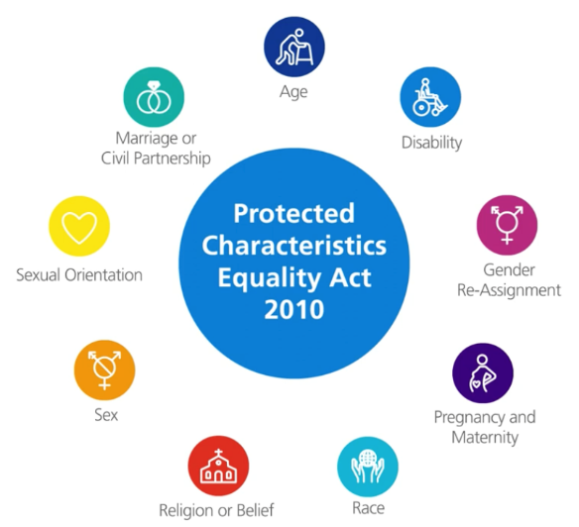

The Councils approach to Consultation and Engagement

- The Consultation and Engagement Strategy sets out the Council’s aims and principles.
- The Consultation and Engagement Toolkit is a guide to support with understanding how to plan and organise consultations, legal requirements, how to engage with groups that are seldom heard, and how to feedback results and evaluate consultation and engagement exercises.
- An internal Consultation database of which will contain details of the Council’s consultation activity, the findings from those exercises and how they have been used.

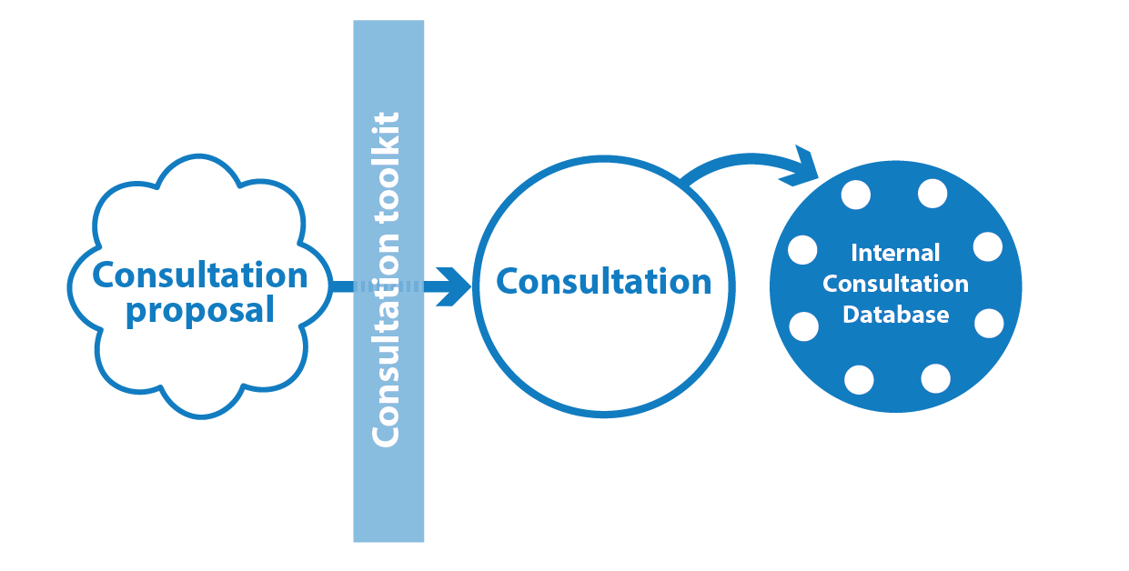

Responsibilities

The roles and responsibility of the officer undertaking the consultation includes:

- Deciding the purpose of the consultation/engagement
- Deciding when and how to consult/engage
- Ensuring equality of opportunity when consulting and engaging
- Deciding how responses will be analysed
- Deciding where responses will be fed back to
- Collaborate with colleagues on design of the survey
- Collaborate with colleagues in communications on design and marketing and promotion of consultation. Public engagement.
- Analysing and reporting back results

Inclusion and Engagement
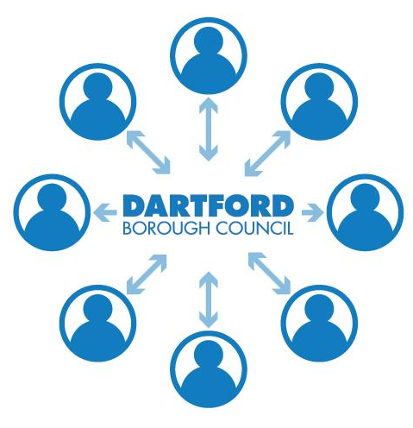
The range of groups with which the Council might consult is extensive.
It includes service users, potential service users, interest groups, partners, business and industry and other stakeholders.
It is important to ensure that consultation is inclusive has different accessibility requirements and that is has consideration of on and offline engagement. We want everyone to have the opportunity to get involved and help shape the future of Dartford
We will use a variety of different methods to ensure that the people of Dartford have an opportunity to have their say and to ensure that their different voices are heard. There are various mechanisms through which individuals and groups can engage with and help to influence services provided by the Council and other public services.

Sharing Results

We will be open and transparent when sharing results and make clear links to actions taken as a result of public feedback, which have led to policy development and service improvement. Results and outcomes will be posted on the Council’s website and will be communicated through local and online media as appropriate.
