

Consultation and Engagement Toolkit
Guidance for staff
2026-2028

Table of Contents
Section number | Section title | Page
1.0 | Introduction | 3
2.0 | Deciding the purpose of the Consultation | 5
3.0 | Deciding when and how to Consult and Engage | 6
4.0 | Ensuring equality of opportunity when consulting and engaging | 11
5.0 | Analysing and reporting back results | 13
6.0 | Starting the analysing process | 14
7.0 | Feedback the results | 14
8.0 | Why we do feedback? | 15
9.0 | Things to keep in mind when capturing responses | 15
10.0 | Archiving a Consultation | 16
11.0 | Data Protection | 16

Section number | Section title | Page
APPENDIX 1 | Consultation Checklist | 17
APPENDIX 2 | Consultation Database Guidance | 20
APPENDIX 3 | Consultation Methods | 25
APPENDIX 4 | Corporate Equality Monitoring Form | 30
APPENDIX 5 | We Asked, You Said, We Did template | 31
APPENDIX 6 | Anonymised Examples | 32

Consultation and Engagement Toolkit

Guidance for staff

Consultation and Engagement Strategy

Overarching Policy

Version Control
Document title | Document version number | Document date | Review date
Consultation and Engagement Toolkit | 1 | 2015 | 2018
Consultation and Engagement Toolkit | 2 | 2019 | 2022
Consultation and Engagement Toolkit | 3 | 2026 | 2028

Consultation and Engagement Toolkit
Guidance for staff

Introduction
  - Dartford Borough Council is committed to consulting and engaging with people who live and work in the area. The Council’s overall approach to consultation and engagement is set out in the Council’s Consultation and Engagement Strategy. This document is designed to complement the Strategy by providing guidance to staff on the appropriate methodologies which can be used to consult and engage and to set out standards for consultation and engagement as well as how the information gained should be analysed and used.

  - Levels of involvement: There are three different levels of involvement:

Consulting: This is defined as the ‘dynamic process of dialogue between individuals or groups, based upon a genuine exchange of views, with the objective of influencing decisions, policies or programmes of action. A key element of consultation is using the responses given to inform the decision making process.

Engaging: This involves working with local people and groups to come to joint decisions about how new policies should be developed or new services should be provided. This is a step beyond consultation, which tends to ask people what they think about a proposal, as with engagement local people are actually involved in producing the proposal.

Informing: This is giving people information about service plans and new initiatives usually after the decisions have been taken about how they are to be implemented. Please note that informing is not consulting, as people will not have the ability to change what is proposed - this needs to be made clear to the target audience.

Informing is seen as being a one-way process, with no channel for feedback. It is about letting people know about decisions which have already been taken and no choices are available to local people to input their views.

When ‘informing’ people, refer to the Communications Strategy for guidance.

  - The Gunning Principles: These are a set of legal rules that public bodies must follow when carrying out consultations. There are four principles, as follows:

    - Consultation must take place when the proposal is still at a formative stage: Consultation cannot take place where the decision on which you are consulting has already been made. Otherwise, the consultation is not only unfair, but the outcome has been pre- determined. Consultation should therefore take place at a stage where responses received can have an impact on the decision, and while the consulting body still has an open mind as to the outcome.

    - Sufficient reasons must be put forward for the proposal to allow for intelligent consideration and response: Consultees must be given sufficient information about the proposal so they can understand what is being recommended and respond accordingly. Therefore the consultation needs to provide enough information to consultees for them to be able to make intelligent choice and input in the process.

    - Adequate time must be given for consideration and response: Consultees must have enough time to consider the proposals and provide feedback. Equally, the Council (as the consulter) must have enough time to consider representations and make a decision. Time is not the only factor in this principle as consultees must have sufficient ‘opportunity’ to take part.

    - The product of consultation must be thoroughly taken into account: The Council (as consulter) must show that it has conscientiously taken account of responses received before making a decision. A failure to report the views of consultees to the relevant Council decision-makers can make the process unlawful. If the decision-maker does not properly consider the material produced by the consultation, then it can be accused of having made up its mind; or of failing to take into account a relevant consideration.

  - These principles are the standards for a correct consultation exercise. Failure to follow these principles could lead to the decision taken following the consultation being challenged through the process of Judicial Review and ultimately the decisions being quashed by the Courts.

  - About this Toolkit: This Toolkit is divided into four stages:

    - Deciding the purpose of the consultation and engagement
    - Deciding when and how to consult and engage
    - Ensuring equality of opportunity when consulting and engaging
    - Analysing and reporting back results

  - There is an expectation that, where there are statutory requirements that set out the process for involving stakeholders in decisions made by the Council, these must be regarded (for example, planning applications have statutory requirements on consultation timescales, the information provided and means of consultation). Please note this Toolkit does not cover the specific details of such individual statutory requirements.

  - After the four stages have been considered, it is important to note that before any consultation begins, the Communications team must be consulted to ensure the proposal aligns with the consultation plan. Once this has been confirmed, the proposal must be approved by the Leadership Team. Following sign-off, ICT can then be contacted to assist with designing the survey.

  - When undertaking any form of consultation and engagement work the Consultation Checklist at Appendix 1 should be followed. This checklist highlights the various matters you should consider before, during and at the end of a consultation exercise.
  - Every consultation carried out should be recorded on the internal Consultation Database on the Intranet. Please refer to Appendix 2 for guidance on accessing and using the Consultation Database.
  - At the end of the consultation, you will be required to use SNAP Surveys (Desktop version) to analyse the data captured during the consultation period. Please use Appendix 5 as a template to summarise your data which will inform the public on the Dartford Borough Council website. This is an important part of the process to ensure that those who took part feel their views were considered during the decision-making process.

Deciding the purpose of the Consultation and Engagement
  - Before embarking on any consultation exercise the following questions will need to be answered:
    - What information is required from the exercise? Do you want to find out whether people agree with the proposal, or are satisfied with the service? Do you want to be able to quantify public opinion and obtain results which are broadly representative of local views? If so, a quantitative method should be used. If on the other hand you want to find out about the detailed views of a group of people on a subject then a qualitative technique will be more appropriate, such as a focus group.
    - Another method is the use of social media: social media describes a
range of web-based tools which allow users to easily create and share content – including text, images and videos – and connect directly with other users to build communities and communicate with each other. In this guidance we use the term to include:
      - blogs and microblogs (such as WordPress and Twitter)
      - social networking sites (such as Facebook and LinkedIn)
      - content communities (such as YouTube and Flickr)
      - collaborative projects (such as Wikipedia), and
      - internet forums and online discussion boards
Social media is normally publicly accessible and allows many people to see, comment on or co-produce materials. The tools are usually free or low-cost and simple to use. Most importantly, social media content is designed to be shared, and it is usually possible to forward, link to or re-publish information with just a few clicks.
The barriers to entry are very low and the potential audience is very wide.
Social media must always complement, rather than replace, traditional methods.
If you intend to use social media you will need to comply with Section 2 of the Council’s Social Media Policy.
    - Engaging with individuals and communities: Who do you want to involve in the exercise? Are you looking at a particular group such as young people, people from a particular geographic location or the population in general? How will you engage those groups? A reasonable and proportionate attempt should be made to engage with and obtain the views of stakeholders with significant interest about the issue you are consulting on. You need to therefore think about how you will ensure you reach your target audience.
    - Do you and your staff have the necessary skills to undertake a consultation and engagement exercise? Dartford Borough Council ICT department can support in the creation of a qualitative or quantative data questionnaire/survey.

    - What resources are available for undertaking the exercise? This includes both finance and time. Remember, even if you are not using an external supplier, there will be costs involved in producing and sending out questionnaires and in analysing returns. Focus groups can include the costs of paying participants, moderating the meeting and transcribing recordings of the discussions. Interpreting may also be required by participants, which will add to costs. If you are using social media then you will need to refer to Section 2 of the Council’s Social Media Policy.

Deciding when and how to Consult and Engage
  - When to consult: Knowing when a consultation is required is essential for ensuring that the decision being made is lawful. Local authorities have certain legal requirements to consult, including:

Statutory provisions: Specifically state that a consultation must occur, for example:
    - Environmental Impact Assessments must be carried out to determine the degree of environmental impact when deciding whether to grant planning permission. The public must be given an opportunity to give their views about the proposed development and the Environmental Statement.
    - Under the Equality Act 2010, equality assessments must be carried out to demonstrate that decision makers are fully aware of the impact that changes may have on protected characteristic groups. Consultation is a key element of informing equality assessments (the equality provisions are covered in more detail in Section 4).
    - Best Value Duty Statutory Guidance require public authorities to consult representatives of a wide range of local persons when reviewing service provision.

Doctrine of Legitimate Expectation: This doctrine is one of the Court’s controls over the exercise of a decision-maker’s powers. The general principle is that the Court will intervene to prevent a decision-maker from making a particular decision (or will quash a decision that is already made) where the decision-makers prior actions or inactions would make it unfair for that decision. The doctrine applies in the following circumstances:
    - When there has been a clear promise of consultation;
    - Where official guidance or policies imply a promise to act in a particular way;
    - Where there is a withdrawal of a benefit with significant impacts to be considered;
    - Where the nature of the relationship would create unfairness if there were to be inadequate consultation.

  - How to consult: It is important to choose an appropriate consultation for the type of information you want to obtain and the chosen method must be appropriate for the intended audience. Appendix 3 sets out the advantages and disadvantages of the methods available.

  - Where it is decided to use a quantitative method such as a questionnaire, the following requirements of the Market Research Society should be followed:

    - That questions are fit for purpose, in that they will meet the aims of the research.
    - That the design and content of questionnaires are appropriate for the audience being researched i.e. the questions are not overly complex or use technical language. In general, self-administered surveys should not be more than four pages in length and questions should not exceed 25 words.
    - That respondents can answer the questions in a way that reflects the view they want to express; there should be a space for “any other comments” left at the end of questions.
    - That respondents are not led towards a particular answer through the framing of the question or the use of additional material sent with the questionnaire; recognised scales should be used such as “strongly agree”, “agree”, “neither agree nor disagree”, “disagree”, “strongly disagree”, “don’t know”.
    - That answers are capable of being interpreted in an unambiguous way; only ask one question at a time, don’t try and frame two issues in one question.
    - That personal data collected is relevant and not excessive. The questionnaire should also include a Data Protection Statement and a Corporate Equality Monitoring Form Appendix 4.

  - Where possible questionnaires should be piloted with colleagues from other sections or partner agencies to identify any potential problems.
  - Where a qualitative method is being used the following requirements of the Market Research Society should be followed:
    - Ensure that any database used to recruit interviewees are compliant with data protection rules i.e. they are registered for research purposes, this is especially true where a third party is to be given access to a database.
    - Where an interviewee asks where their details have been obtained from, they must be told.
    - If there is to be any recording, monitoring or observation during an interview, interviewees must be informed about these both at recruitment and at the beginning of the interview. Interviewees must be told the name of any observer present at the interview and who they represent. If an observer recognises an interviewee the observer must withdraw.
    - Interviewees should also be told the name of the interviewer, the subject of the interview (particularly if a sensitive or potentially distressing subject is to be discussed), what will happen to the results, the location of the interview and the likely length of time the interview will take.
    - If a fee is to be paid for taking part or expenses are to be met then this should be made clear both at the time of recruitment and at the beginning of the interview, with details of how payment is to be made.
    - All interviewees must be made aware of their right to withdraw from the process at any point.
    - No recordings made of interviews can be given to a third party without the express consent of all the interviewees taking part. An anonymised transcript of the interview (where more than one person is present) can be made available to third parties without permission.

  - Research with children and young people: It is good practice to invite the views of children themselves when you are designing your policies and/or services, including diverse groups who can provide a range of feedback. This can help you identify risks, design safeguards and assess understanding, as well as giving you an opportunity to test your system or product on the end user.

Following the UN Convention on the Rights of the Child, children and young people are defined up to the age of 18 unless, under the law applicable to the child, majority is attained earlier.

The General Data Protection Regulation contains provisions intended to enhance the protection of children’s personal data and to ensure that children are addressed in plain clear language that they can understand.

As a matter of good practice, the Council’s Consent Guidelines should be complied with irrespective of the age at which children or young people are presumed for the purposes of this Toolkit, to be of sufficient age and maturity to provide their own consent. The procedure for obtaining consent is as detailed in the Consent Guidelines.

Where research with children and young people is to take place advice must be sought from the Policy and Corporate Support Team. The Market Research Society provides further Guidelines for Research with Children and Young People, which is summarised as follows:
    - Permission from a responsible adult (parent/guardian, or in a school setting, the head teacher) must be obtained for a child under 16 to participate in a research project.
    - Permission should be obtained in a way that is verifiable (i.e. in writing) and the identity of the responsible adult giving permission is recorded by name and relationship/ role.
    - Responsible adults should be given sufficient information about the project to enable them to make an informed decision.
    - The child or young person should be given a separate opportunity to opt out of the research project.
    - Research with children should not include subjects which are likely to upset or worry a child, which are sexually explicit, which may cause conflict between the child and their carer or involve sensitive family issues such as substance abuse, illness or finance.
    - The content and language used should be sensitive to the language, needs and feelings of the age group to be interviewed and their capabilities. There should be no questions that are unnecessarily intrusive or are difficult for the child or young person to answer, or which might result in a child or young person making unreasonable demands on a parent or guardian.
    - Any researcher in direct contact with children and young people must have had a Disclosure and Barring Service Criminal Record check (the Disclosure and Barring Service provides information on which roles are eligible for a basic, standard and enhanced checks)
    - When, as part of the consultation process an interviewer becomes concerned that a child or young person has been subject to abuse or neglect they should make those concerns known through the Council’s Safeguarding process (please refer to the Safeguarding Policy).
    - Interviewers must never interview an individual child or young person on their own; another adult must always be present.

  - Prize draws: Where incentives are agreed by the Managing Director? and are offered to encourage participation in a consultation and engagement exercise the following requirements from the Market Research Society must be followed:
    - Respondents must not be required to do anything other than agree to participate in a market research exercise or return a questionnaire, to be eligible for entry into a free prize draw.
    - Respondents must be clearly informed, before participating, of:
‐ the closing date for receipt of entry
‐ the nature of the prizes
‐ if a cash alternative can be substituted for any prize
‐ how and when winners will be notified of results
‐ how and when winners and results will be announced
    - Unless otherwise stated in advance, prize winners must receive their prizes within six weeks after the draw has been held.
    - Winners in a free prize draw must be selected in a manner that ensures fair application of the laws of chance. The process by which winners will be selected must involve a clear audit trail and an independent draw. (This process does not have to be made public but can be explained to individual respondents when specifically requested).
    - An observer, independent of the free prize draw organisers, must supervise prize draws to ensure that all participants have an equal opportunity of winning.

  - Raising awareness of your consultation: Reasonable efforts should be made to ensure that everyone with a justifiable right to participate in a consultation is aware of the exercise. If your target audience is not aware of the exercise, they will not have the opportunity to take part and express their opinion. For example, in a public consultation, it is not enough to rely on placing your consultation on the website without making the public aware of its existence on the website.

You should therefore think of how to notify the public of your consultation. This could include using, for example, press releases, social media, mailing lists etc.

Using external organisations: If an external organisation is carrying out consultation on the Council’s behalf, it is important to ensure they have a regard to the aims and principles of the Consultation & Engagement Strategy and this Toolkit.

Ensuring equality of opportunity when consulting and engaging
  - Public sector equality duty: The Equality Act 2010 places a legal obligation on public authorities to have due regard to the need to eliminate unlawful discrimination, harassment and victimisation; to advance equality of opportunity; and to foster good relations, between people with different protected characteristics. The protected characteristics are age, disability, gender reassignment, pregnancy and maternity, race, religion or belief, sex, and sexual orientation.
  - Consultation and engagement is an important tool for helping to comply with the public sector equality duty because it can assist you to understand how the matter you are considering affects (or will affect) different groups of people, therefore contributing to an adequate evidence base for your decision-making.
  - Customer Access Reviews (otherwise known as equality assessments) are the process by which the Council assesses the impact on equality, and they should be carried out before particular decisions are made and at the time of making decisions. You will have some data to inform your Customer Access Reviews, but the outcomes from consultation can be very useful in helping to understand the impact better and are therefore important to feed into equality assessments. For example, a consultation on proposals to reduce a bus service could find that users of the bus service from religious or faith groups will have the ability to attend church affected if the service is reduced on Sunday’s. Customer Access Reviews should form part of the evidence base for decision-making and be conscientiously taken into account by decision-makers.

  - To help you monitor the various groups that respond to a consultation exercise, the Corporate Equality Monitoring Form can be used (Appendix 4). This form is useful to understand our customers so that we design and deliver services that meet their needs. For example, if your consultation is about changes to parking in a town centre, it might be important to monitor respondents by age and disability to understand issues about accessibility. Equality monitoring may also be useful to analyse the demographic profile of
consultation respondents and to monitor how representative the respondents are to the local population.

  - For more information on the Council’s approach to meeting the equality duty, including the Customer Access Review process and corporate equality monitoring, please refer to the Equality & Diversity Document Framework.

  - Identifying barriers to consultation/engagement: Everyone with a justifiable right to participate in a consultation exercise should have reasonable access to the exercise. The methods chosen must therefore be appropriate for the intended audience. Equality of opportunity to participate will encourage better response rates as well as help towards ensuring the views obtained are fully representative of the relevant community you are attempting to consult.

  - There are some groups and individuals who may find it more difficult to get their views heard. This can be because of physical disability, learning difficulties, not having English as a first language or having literacy difficulties, and social restrictions. In other cases, there may be social issues which act as a barrier, for example in poorer communities where there may be a feeling that their views are not valued by public agencies.

  - These issues need to be taken into account when designing a consultation or engagement exercise. You may want to consider contacting particular community groups or organisations in order to help you access a target population, for example the Kent Cohesion and Equality Council or local Mosques/temples if you want to speak to a particular minority ethnic group, or the Elders Forum or Age Concern if you want to talk to older people. Further information can be obtained from the Growth and Communities (Policy and Corporate) Team.
  - You should consider the timing of the consultation. July and August are not good for maximising responses as this is the summer holiday period, similarly Christmas is not a good time to undertake research. If research is being carried out with black and minority ethnic groups, then you need to be aware of other religious events or festivals which may affect response rates. You should also be aware that the timing of consultation events can affect attendance. Day time events, held during the week, will miss those people who work during the day. Evening events, particularly during the period of darker nights, may discourage some people from attending.
  - It is therefore important that you are clear about the audience you are seeking to engage with before designing an event.

  - You also need to consider the accessibility of any venues to be used e.g. wheelchair access, accessible toilets, induction loops, accessibility by public transport and the provision of disabled parking facilities. If refreshments are to be provided ensure that the dietary needs of the groups involved are reflected, for example the provision of a vegetarian option separated from meat products.
  - The design of written materials also needs to take into account the needs of particular groups. Questionnaires and other written material should be produced in a minimum of 12 point and Arial is the preferred type font. Translation of documents should also be available, including Braille and
Audio Tape (see the Equality & Diversity Document Framework for the Translation & Alternative Format Policy). Documents should always be produced on matt paper as glossy paper can cause difficulties for people with visual impairments.
  - Where work is being undertaken with people with low levels of literacy or learning difficulties a more pictorial style should be used for any presentational material.

  - Use welcoming venues, people may find a formal committee setting intimidating.

  - Try using less formal formats for events as “meetings etiquette” with agendas and formalised ways of addressing participants may deter participation.

  - If using an online consultation method, consider how you would ensure that those without access to the internet or the capacity to use the internet have an alternative means of accessing the consultation. Be wary of relying on only one method to reach your audience and only one method for your audience to respond to your consultation.

Analysing and reporting back results

  - Evaluation of consultation results is important because it provides a way of letting those who have engaged with your consultation know the outcome. How you are going to evaluate the consultation findings should be considered at the start of the consultation process not at the end. Once your consultation has closed, the intelligence captured through the different consultation methods will provide the findings for your decision makers report. Appendix 5 will be used as a template to capture and provide a summary of responses using the “We Asked, You Said, We Did” method.

  - It is important to remember that Consultation results must be kept confidential and secure and you should ensure that nothing is published or reported that would breach any promises of anonymity or disclose personal/sensitive information.

  - To meet your public sector equality duties, you need to understand responses in relation to equality groups or "protected characteristics" of people that have been identified as particularly pertinent to the consultation - both those who replied and noting under-participation too.

  - There are two different types of data, Quantitative and Qualitative.
Quantitative data (Survey Data): With quantitative data, frequencies and percentages can be used to make points and show trends.
Qualitative data (open-ended questions in survey data and findings from focus groups or face-to-face events): For relatively simple consultations, qualitative data can be gathered under broad headings which will aid subsequent analysis. This can include analysing comments to open-ended questions in your questionnaire, as well as writing up the results from your focus groups or other face-to-face events.

Starting the analysing process

  - Everything you need is available within the SNAP Software. The system includes innovative reporting and analysis tools that help you obtain the insight you need. The User guide and training video can be located on the intranet- Consultation and Engagement- SNAP analysis. The Software has the ability to Produce dynamic and flexible Smart Reports, view an instant summary of survey results, Simplify your data with our Snap Surveys suite of analysis tools and share analysis and reports on and offline.

  - To start the process (refer to section 1.7), please contact ICT Helpdesk who can create the survey on your behalf once they have received all the necessary information. Before the survey is live, ICT will send the draft survey to the requesting office for approval. Once agreed, ICT will provide the Officer with a live link, it is the responsibility of the Officer to upload this to the appropriate platform.

Feedback the results

Once the snap system has analysed data and produced a report the relevant Council decision- makers must conscientiously take into account the consultation results/analysis before making a decision. Feedback directly to those who took part in your consultation and engagement activity is the most important part of the consultation and engagement cycle and you should have a clear plan to feedback.
  - Appendix 5 will support you with applying the “We Asked, You Said, We Did” method. The number of responses received should also be indicated. Consultation responses should usually be published within 12 weeks of the consultation closing. Where this is not possible, a short explanation should be given to explain when feedback can be expected. People often feel that their opinions have not been used when they have not been told of any decisions based on them. Once decisions have been made, report these, with explanations for why decisions were taken.

  - Examples of where else to publish your findings include:
    - DBC Website
    - Local media, newsletters, residents’ magazines, flyers and posters
    - Council sponsored publications – Dartford Living.
    - Sheltered Housing Schemes
    - GP surgeries, community centers, housing office, schools and libraries.

Why do we feedback?

  - It is important to feedback to demonstrate how public views have been used in service development and the decision- making process. If decisions were taken that did not reflect exactly how residents or service users would have liked, explain why. There may be good reasons for certain decisions and the public need to know what these are.

0. Things to keep in mind when capturing responses:
  - Whilst writing up the detailed findings think about the following:

    - Which findings do not require action? E.g. low priority or results that are very good
    - Which things can we not change in the short term? How do you tell people?
    - Popular recommendations that cannot be taken forward require an explanation as part of your feedback
    - Which things can we change in the short term? Identify "quick wins", especially those that can be done within existing budgets or timescales. This demonstrates that you can and will act on the outcomes of consultation.
    - Which results highlight the need for action?
    - What are the next steps, who needs to know?
    - Does funding need to be identified, is further consultation needed, when can decisions be taken?
    - Which results highlight the need for more communications? What is the issue, how will you communicate it, to whom and where?
    - Which results highlight the need for further consultation? In some circumstances new alternatives will come to light which may call for further consultation.
    - This always takes longer than you think so allow plenty of time.

  - Anonymised examples to help you frame completion of ‘We Asked, You Said We Did’ can be found under Appendix 6.

10.0. Archiving a consultation

10.1. Once the consultation has been archived it is advisable to provide a summary of the survey and/or report rather than archiving a large amount of data information. An example of an archived consultation is provided within Appendix 6, Example 3.

11.0. Data Protection
11.1. Some methods of consultation may involve the collection of personal data about respondents. The Data Protection Act 2018 (DPA) protects individuals against the misuse of that data, and all records whether manual or computerised will need to meet the requirements of the DPA.
11.2. The Council’s Corporate and service specific Privacy Notices explain how it processes personal information and individuals’ additional rights. Consultees should always be signposted to the Corporate and relevant service specific Privacy Notices (as applicable) which can be viewed at www.dartford.gov.uk.

  - If as part of your consultation you are collecting data for the purpose of equalities monitoring, this will often fall within the special categories of data under the General Data Protection Regulation (GDPR), i.e. where it relates to ‘racial or ethnic origin, religious or philosophical beliefs, health or sexual orientation’. The Council has a Data Protection Policy setting out the safeguards it has implemented for processing special category data.

  - If you are unsure of any element of your responsibility to comply with data protection requirements and need advice, please contact the Council’s Data Protection Officer.

APPENDIX 1

Consultation Check List
When undertaking any form of consultation and engagement work this Consultation Checklist should
be followed. The checklist highlights the various matters you should consider before, during and at the
end of a consultation exercise.

1 | Do you have a legal duty to consult on the particular matter?  - Consider if there is a statutory provision or a legitimate expectation to consult.  - Are you aware of the three key levels of involvement when carrying out this exercise? | ☐
2 | What is the purpose of the consultation exercise? What do you want to find out?  - Are you familiar with the information required from the exercise?  - Have you thought about who you want to engage with during this exercise, i.e. a particular group like young people, people who live in a certain location etc.?  - Do you understand the skill set required during the consultation and engagement exercise?  - What resources are available for undertaking the consultation exercise? This includes both finance and time.  - How are you going to publicise the consultation? Reasonable efforts should be made to ensure that everyone with a justifiable right to participate in the consultation is aware of it and knows how to access it. | ☐
3 | When and how to consult and engage? You should make reasonable and proportionate attempts to engage with and obtain the views of stakeholders with significant interest in the matter you are consulting on.  - Are you aware of the legal requirements to consult?  - Are you aware of the statutory provisions that state a consultation must occur?  - Have you thought about an appropriate method to consult?  - When do you intend to undertake the consultation? Consider any timing issues which might affect response rates. | ☐
4 | Are you aware of the importance of ensuring equal opportunity?  - Are you familiar with Customer Access Reviews and how they form part of the decision-making process?  - Have you thought about potential barriers to consultation and engagement?  - How are you going to reach consultees who may be seldom heard? It is important to take measures that will help to overcome the barriers that prevent seldom heard groups from taking part in the first place. This may involve using interpreters, using visual aids, adapting facilities for disabled people etc.  - Have the details and exercise been put onto the consultation database? Refer to Appendix 2 for guidance on how to use the database. | ☐
5 | Are you aware of the steps you take to analyse and report back results? This includes understanding the process of analysing data within snap and reporting back results via the “We Asked, You Said, We Did” template (Appendix 5)  - Have you thought about how to evaluate the consultation results so that those who engaged are aware of the outcome?  - Are you familiar with the analysing tool within the system SNAP and how to use it?  - Are you aware of the importance of keeping the consultation results confidential  - Are you aware of the difference between quantitative and qualitive data?  - Have you thought about how you will be presenting your results within the Consultation report?  - Are you aware of the decision-making process?  - Are you aware of the importance of feeding back the results of the consultation and engagement activity?  Remember it is important to give feedback to those who directly took part in your consultation and engagement activity.  - What time have you allocated to the consultation exercise? Consultees must have enough time and opportunity to consider the proposals and provide feedback.  - Are you aware of the decision-making process?  - Are you aware of the importance of feeding back the results of the consultation and engagement activity?  After the keys points noted above have been thought about, below provides guidance of the internal process to support you with analysing and feeding back to those who took part in the consultation  - Dartford Borough Councils ICT department will provide a build survey which will be sent to the responsible Officer to approve and amend where appropriate. This allows enough time for the Officer to adjust the survey to fit in line with data they wish to capture from the public.  - It is the responsibility of the responsible Officer to send the finalised survey back to the ICT department in which they will make available to the members of the public.  - Once the consultation deadline has passed, ICT will provide Officers the link to the survey results which will be read to analyse  - Data is analysed through the SNAP system, guidance on how to do so is available on the intranet folder Consultation and Engagement, under SNAP Surveys - Analysing your Survey Data  After you have analysed the data and made possible considerations where necessary, it is time to think about reporting back to those who took part.  - Using the “We Asked, You Said, We Did” template (Appendix 5) provide a summary of each section which will inform those who took part in the consultation, that their views have been considered.  - The template must be uploaded to Dartford Borough Councils website, on the page in which the consultation was promoted. The consultation feedback response must remain on the website for a minimum of four weeks before removing.  - Think about how else you can report back to those who took part. | ☐

6 | If you are collecting personal data on the respondents to your consultation, have you ensured you will be complying with data protection requirements? Consultees should always be signposted to the Corporate and relevant service specific Privacy Notices. | ☐
7 | Remember, before any consultation can begin, the Communications team must be consulted with to ensure the proposal aligns with the consultation plan. Once this has been confirmed, the proposal must be approved by the Leadership Team. Following sign-off, ICT can then be contacted to assist with designing the survey. | ☐

APPENDIX 2

Consultation Database Guidance

Introduction:
The Consultation Database is an internal database on the SharePoint (the Intranet) for use by Council officers. The purpose of this database is to log details of every consultation and engagement activity that the Council carries out with people who live, work and visit the Borough, including the findings from those exercises and how they have been used.

If you are planning to carry out a consultation, this guidance should be read in conjunction with the following documents:
  - Dartford Borough Council Consultation and Engagement Strategy
  - Dartford Borough Council Consultation and Engagement Toolkit

Both of the above documents can be found on the Consultation and Engagement Page on SharePoint. When you are ready to log your consultation, please follow the below steps.

Step 1- Access the Consultation Database
You can access the database from SharePoint. Click on Really Useful Links, then click in Consultations

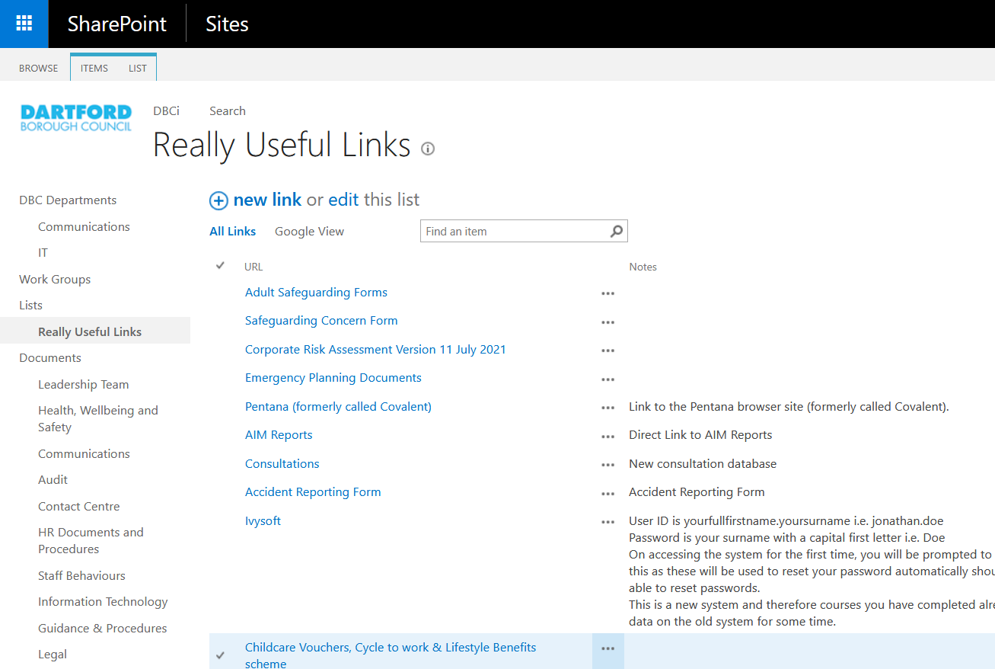

Step 2- Add a Consultation Record

Click on Items, and then click on New Item

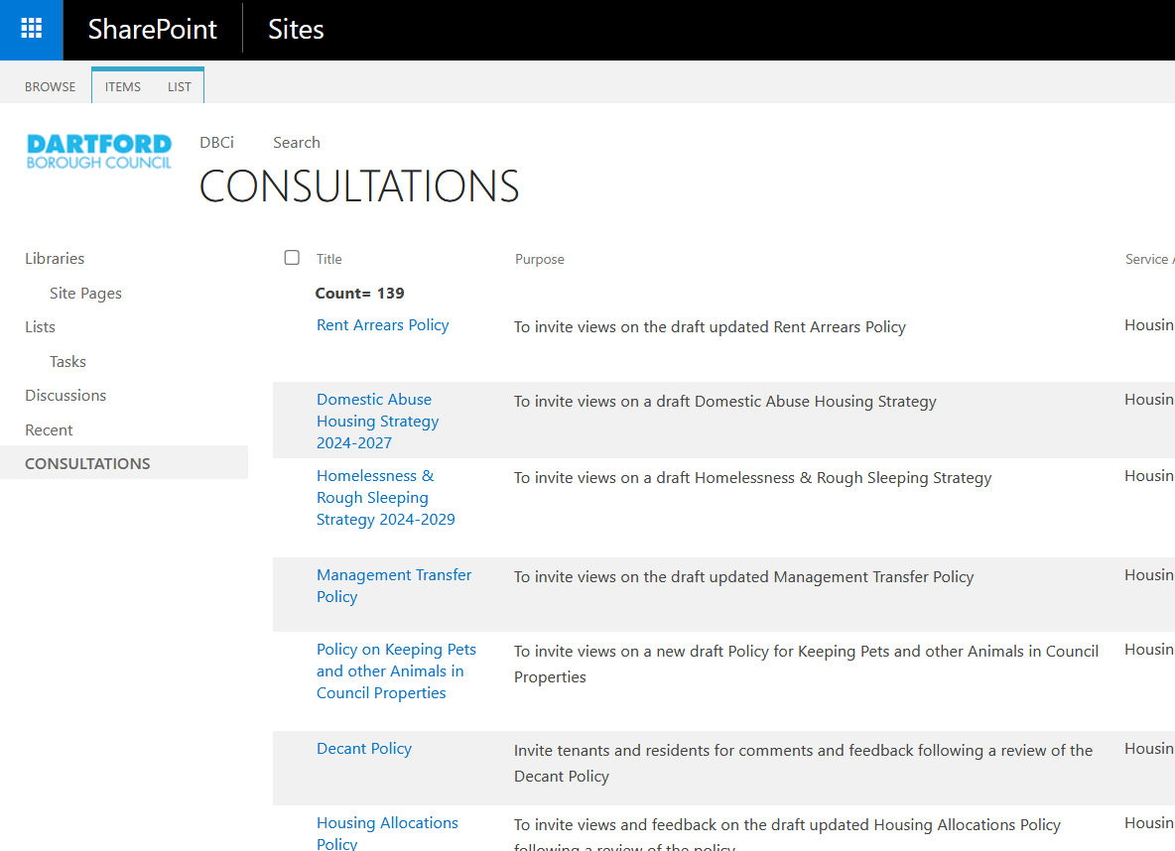

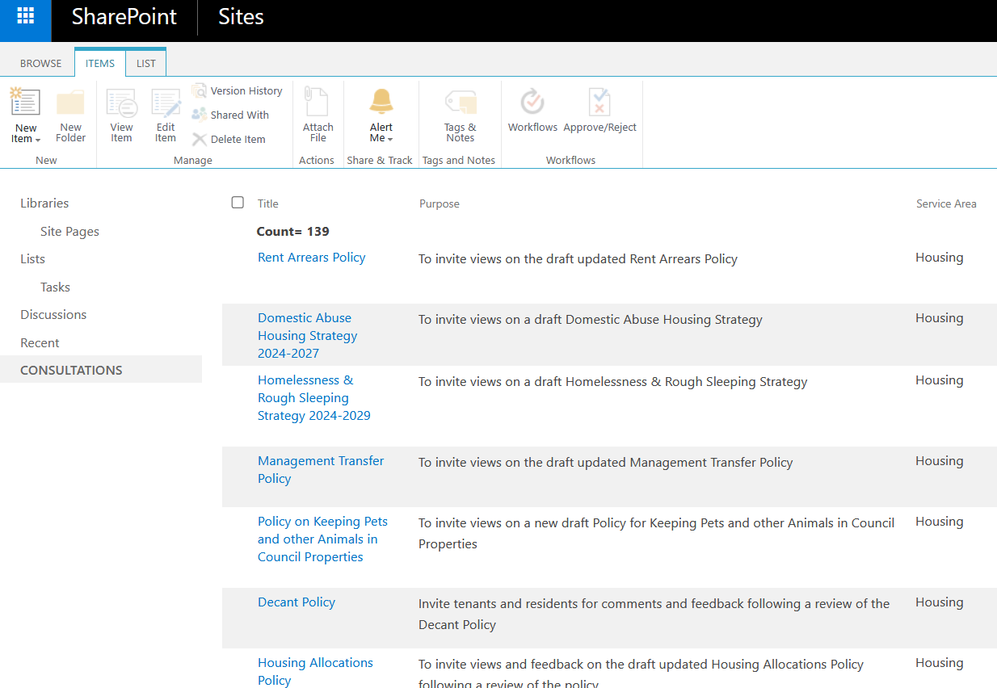

Step 3- Add a Consultation record

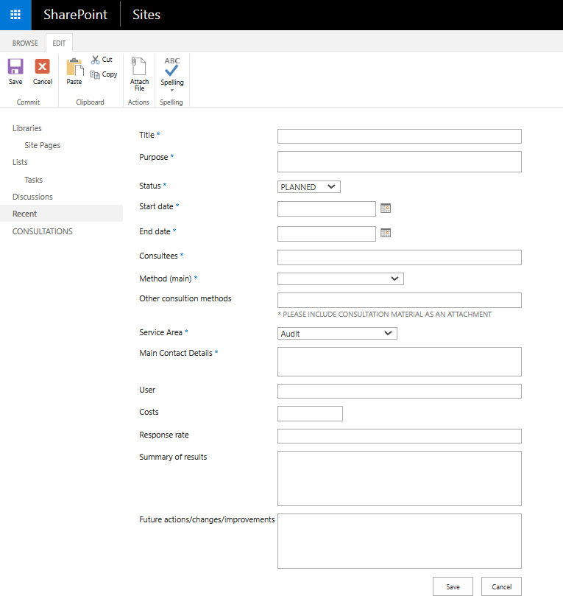

- If you are planning a consultation or have just started a consultation you should first complete the fields from Title through to Costs (if known).

- When you have completed the consultation you should go back into the record by clicking on the Title, then click on Edit Item to update the Status from either Planned or Started to Complete and then complete the fields from Response rate through to Future actions/changes/improvements.

- It is advisable to set yourself a reminder for after the consultation closing date to prompt you to update and complete the consultation record.

- The user who inputs the consultation record is the only person able to update, amend or delete the record. All other users can view the record only.

- The below table gives advice on the type of information required for each field in the form.

Field | Information required
Title * | Title of the consultation
Purpose * | Aims and objectives of the consultation
Status * | Status is either planned, started or completed
Start date * | Start date of the consultation
End date * | End date of the consultation
Consultees * | Who you consulted (e.g. members of the public, council tenants, young people, voluntary groups)
Method (main) * | Main consultation method used (e.g. survey, focus group, referenda, consultation document). You can refer to the Consultation and Engagement Toolkit for an explanation of each consultation method listed in  the drop-down menu
Other consultation methods | If you are using other consultation methods in addition to the main method, list these here. You can also attach the consultation materials used (e.g. surveys, flyers, interview questions), or you can insert website  links
Service Area * | The department carrying out the consultation
Main Contact Details * | This is the person who is leading the consultation. Please include their name, extension number and email address
User | This is the person who is inputting the consultation record into the database. This may be different to the lead person carrying out the consultation
Costs | The costs of the consultation, if known
Response rate | How many people were consulted (e.g. the percentage of people who responded to a survey, the number of people interviewed, the number of people  who attended a focus group)
Summary of results | The headline results from the consultation. You can  also attach documents or insert website links
Future  actions/changes/improvements | The actions, changes or improvements undertaken  as a result of the consultation

Step 4- Checking records on the Consultation Database

The database contains columns for the Title of the consultation, Purpose of the consultation,
Service Area, Start date, Status and Summary of results.

If you wish to look for certain records (e.g. all consultations carried out by Housing Services), it is possible to filter the database columns by clicking on the column title. To view the full consultation record, click on the Title of the consultation.

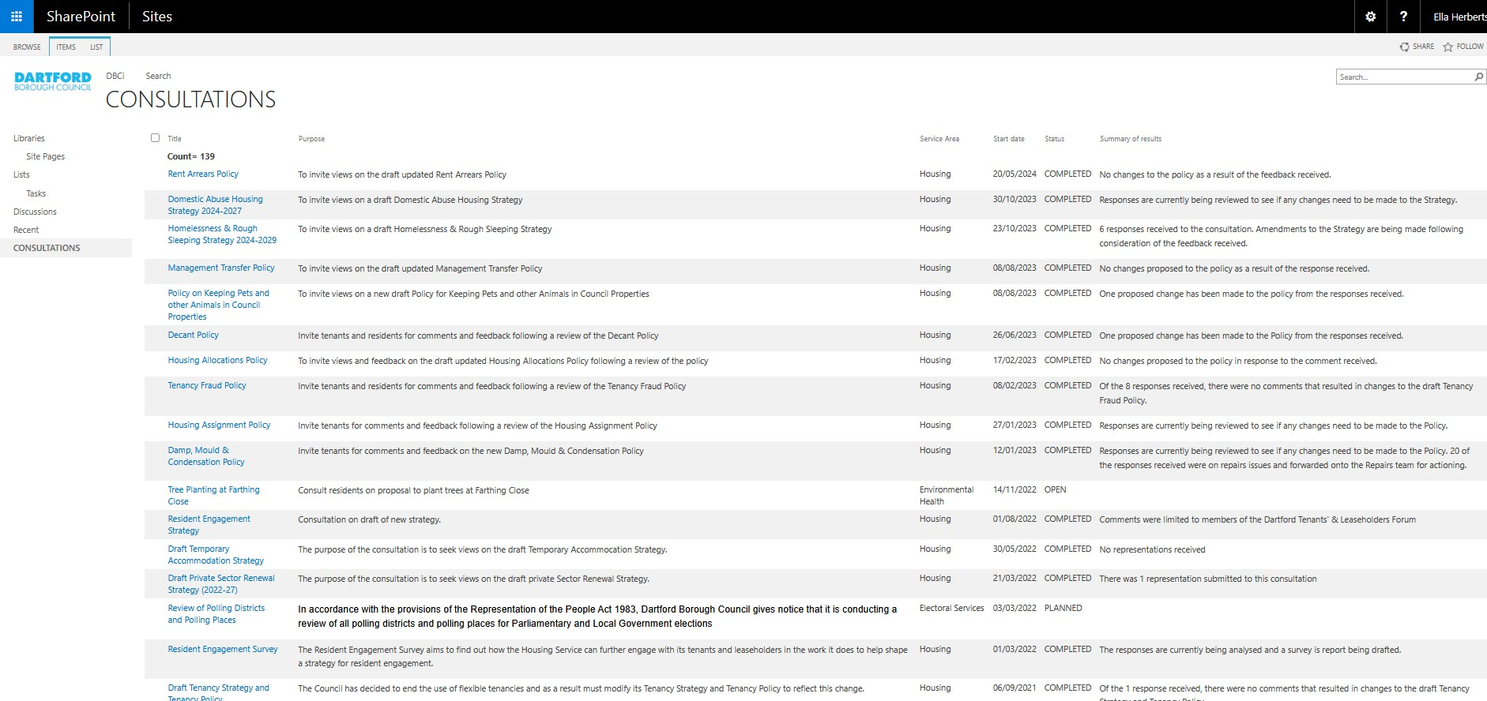

APPENDIX 3

Consultation Methods

Method | Considerations | Advantages | Disadvantages
Ward Councilor Contact  A contact point for citizens to express their views and concerns about issues that affect them. | - Hold at times/locations to suit constituents  - Accessing seldom heard constituents | - Good for public relations  - Makes people feel that they are being listened to and that their issues matter  - Enhances the representative role of local councilors | - Limited and unrepresentative perspective
Area Forums  Meetings which provide an opportunity for local residents and Ward Members to discuss issues of local concern. Acts as a focal point for community engagement on a Ward basis | - Use when you have an issue that needs a public airing and publicity  - Use when you do not require ‘data’ | - All Ward Members involved  - Regular meetings  - Limited decision making powers allows community access to Members and officers  - Open to all | - Can be overly influenced by some people  - Not truly representative  - Difficult to reach consensus  - Requires skilled chairing and management  - No one time or place suits everyone
User Panel  A small group of users that meets regularly to provide input on service delivery and development over a long period of time. | - Small size, no more than 12  - Have clear objective and timeframe  - Moderation of group | - Gives user perspective  - Group has knowledge, experience and understanding of the issue/ service  - Ongoing dialogue  - Membership can be rotated to maintain a balance of old and new members  - Opportunity for direct liaison and feedback between panel members and service providers | - Limited and not necessarily representative perspective  - Group can grow too close and lose objectivity  - Cannot be used for a wider range of services  - Does not address needs of non-service users  - May exclude minority groups
Referenda  A formal poll on a single issue. Asks for a response to a single question. Can be postal or traditional.  The outcome (that is, a ‘yes’ or ‘no’) is binding. | - Initiated by government  - Issue should stand on its own (not overly complex)  - Results usually binding | - Opinion of entire population can be obtained quickly and efficiently  - Postal ballots can be used to improve turnout  - The organisation must act on the outcome  - All voters are equal  - Incites discussion | - Expensive  - Limited use  - Requires publicity to improve response rate  - Should only be used for issues that require little or no explanation  - Can only give a yes/no response or a choice between limited options
Community Needs Analysis  Framework for detailed overview of small area. Involves a range of stakeholders to determine actions following research on complex issues. | - The council Snap Survey database can analyse data on behalf of the officer. | - Snap provides very detailed analysis of issues thus ensuring decisions are evidence-based | - Expensive and time consuming  - Possibly leads to over expectation  - Needs to be managed effectively
Citizens’ juries  Small sample of population (usually paid) who debate an issue in a quasi-judicial setting with witnesses.  Aims to obtain informed and considered opinion or verdict on a specific, often controversial issue. | - Requires skilled moderator  - Commissioning body must follow recommendations or explain why  - Need to be clear about how to use results  - Consensus not required | - Develops deep understanding of issue  - Can be used to address very complex and controversial issues  - Participants can be made fully aware but can still come to a decision from a ‘lay’ perspective  - Public identify with representative citizens | - Expensive  - May not be representative  - Difficult to include all interest groups  - Can be time-consuming and resource intensive  - Not suitable for all issues  - Extensive preparatory work
Future Conferencing/ Visioning Considering future scenarios and ways to influence outcomes in uncertain situations. | - Independent and skilled facilitator  - No pre-set proposals  - Seeks consensus | - Creates a real sense of involvement using local knowledge and understanding  - Can build consensus  - Promotes community ownership of the results  - Allows many viewpoints and exchange of information | - Time consuming  - Resource intensive  - Can raise unrealistic expectations  - Costly  - Difficulty in reaching consensus  - Can be captured by large interest groups
Physical Planning Structured consultation method that uses a 3D plan of the neighbourhood to ascertain what physical changes people want for their local area. | - Use when you have an issue that needs a public airing and publicity  - Hold at times/locations that maximise involvement | - Can be available as a tailored package, so easy to set up  - Is entertaining and involves those who would not normally participate  - Makes it easy to obtain honest and wide-ranging opinions  - Can deal with complex issues | - Difficult to ensure representation  - Can be a costly exercise  - Size of the model limits how many people can be involved  - Numerous models may be required
Focus Groups Facilitated group discussion to explore issues in depth and seek views of particular interest groups. Can be used to generate ideas. | - Requires skilled facilitators  - Selection of group of prime importance  - May need several groups to gain different perspectives  - Generally 8–10 people per group | - Allows brainstorming of ideas  - Can be designed to involve hard-to-reach groups  - Can explore complex issues  - Provides in-depth information  - Useful for building on survey findings  - Allows interaction and spontaneity between participants | - Can be costly and time- consuming  - Requires specialist expertise to facilitate discussion  - Lack of confidentiality  - Can only achieve limited representation  - Discussions can be difficult to transcribe and analyse
Surveys – Self- completion  Market research exercise used to gather quantifiable information on uncomplicated issues.  Can be used to gather views and opinions and to measure attitudes, satisfaction and performance. Postal surveys usually used. | - Needs statistical and research expertise to administer and avoid bias  - Most suitable for attitudinal surveys  - How to access hard-to- reach groups  - How to provide feedback to respondent | - Effective way of quickly gaining information from a lot of people  - Analysis relatively straight forward  - Data can be compared against local and national benchmarks  - Can be used for sensitive issues  - Open-ended questions can explore issues in-depth. | - Can be labour intensive and expensive  - Unsuitable for complex issues  - Open-ended questions difficult to analyse  - Can yield a low response rate  - Difficult to engage with  - hard-to-reach groups  Cannot be certain of veracity of responses
Surveys – Telephone Telephone interviews with a sample of residents or service users, sample normally 1000 respondents plus | - Needs statistical and research expertise to administer and avoid bias  - How to access hard-to- reach groups  - How to provide feedback to respondent  - May need external resources and trained researchers | - Can ensure a good response rate  - Easier to engage with hard-to- reach groups  - Can be used to obtain responses from demographically representative sample  - Allows flexible structure of interview  - May be used to explore sensitive issues demographically representative | - Interviewer cannot respond to any questions  - Not necessarily representative  - Can be costly and time consuming  - Specific skills are required to conduct the interview
Citizens’ Young Persons’ Panels  Comprise between 500 and 2,500 citizens who are demographically representative of the population. Used as a sounding board to test, assess and develop proposals over an extended period of time. | - Panel members need to be clear of their roles  - Can be conducted in partnership with other organisations | - Demographically representative  - Readily available ‘pool’ of willing respondents  - Can yield a good response rate  - Relatively cheap once the panel has been set up  - Can be targeted  - Track views over time | - Cannot be used for complex issues  - Can be expensive and time-consuming to set up  - Risk of over-consulting  - May not be representative as panel self-selecting and want to be consulted  - Panel may become experts and conditioned to providing the right answers  - Panel membership needs to be refreshed regularly
Consultation Documents To provide information and invite public submissions or written comments on specific proposals. | - Writing and editing skills needed  - Administration of responses/ feedback  - Full details need to be provided  - Publicise event  - Allow time to respond | - Good starting point for consultation  - Provides detailed information on the issue  - Elicits a considered view | - Can be costly to produce and circulate  - Not always read by target audience  - Needs to be accessible by all, e.g. other languages, etc  - May have poor response rate  - Resource intensive
User Comments & Complaints  Provides a system for direct feedback from service users. | - Make feedback forms accessible  - Data confidentiality  - Determining if failures one-off or general | - Easy to set up  - Provides input from service users  - Can identify weaknesses and strengths  - Formal mechanism for pursuing a complaint | - Unlikely to yield positive comments  - Not representative  - Essentially reactive to existing systems
Forums  Structured and regular meetings with interest groups. Used to provide information, seek views and develop/endorse local plans and strategies for the community or whole town. | - Needs effective management | - Regular process of engagement  - Useful link between partner agencies and local people  - Can be used to seek local committed involvement  - Relatively cheap | - Attendees are unlikely to represent all views  - Can be dominated by the most vocal.  - Agenda can be taken over
Advisory Committees A group to advise partner agencies on policy decisions and services. Group may consist of professionals and/or key stakeholders. | - Define roles and responsibilities  - Be forthcoming with information  - Interview members before selection  - Ensure members communicate with their constituents | - Can use existing groups  - Permanent, regular method  - Group will be familiar with issues  - Group are able to give advice from a variety of perspectives  - Can offer an expert opinion | - May not be embraced by general public  - Members may not reach consensus  - People may become experts and/or be unrepresentative  - Can only involve limited number of participants  - Time and labour intensive
Seminars/Workshops A formally organised discussion group to exchange and gather  information. Usually in the format of presentations followed by small group discussions, ending in a large group discussion of key issues. | - Requires skilled facilitators | - Opportunity to share large amounts of information  - Large numbers of people can participate  - Opportunity for dialogue between all key stakeholders  - Opportunity to engage in multi-disciplinary discussions  - Participants can ask questions and explore issues in detail  - Encourages participants to network and share experiences | - Requires a great deal of organisation and specialist moderation skills  - Can be costly and time consuming  - Can be dominated by the most vocal.
Staff Feedback and Suggestions Provides a system for  feedback and suggestions from frontline staff who deal with the public. | - Train staff to deal with complaints  - Establish feedback systems | - Show you value staff and are open to suggestions  - Valuable source of information on service use and users | - Relies on staff participation  - Time consuming  - Not necessarily representative
Website  Using information technology to inform and gather feedback, e.g., online questionnaires | - Access to computers may be limited | - Cost effective  - Quick response rate  - Easy to keep information current  - Potentially wide-reaching  - Can be used to engage with some hard-to-reach groups  - Useful for panel surveys. | - Will not reach everyone  - Requires technical expertise  - May exclude some groups, e.g., elderly, low income  - Results can be unrepresentative
Public Meetings  Formal meetings with scheduled agendas. Used to provide information, seek views and develop/ endorse local plans and strategies for the community or whole town. | - Hold at times/locations to suit target communities  - Publicity for event  - Clearly defined objective  - Defined meeting structure  - Staffing and facilitation | - Opportunity to provide information and receive feedback.  - Builds relationships with local community  - Can be used to seek local committed involvement  - Relatively cheap  - Allows public to let off steam | - Attendees are unlikely to represent all views  - Large group may be a barrier  - Can be dominated by the most vocal  - Turnout can be poor  - Can be difficult to separate individual and general complaints
Publicity  To provide information and to obtain views on specific projects or services | - Writing and editing skills needed | - Potential for regular updates  - Can reach a wide audience | - Can be costly and time consuming  - May be seen as junk mail  - Not always read by target audience  - Media coverage may slant the story
Exhibitions and Road shows  Used to provide information and to obtain views  on specific projects or services. | - Suitable venues  - Publicise the event | - Effective in publicising services/organisation  - Gives public flexibility to attend  - Allows contact with public | - Groups reached dependant on location/ timing of roadshow, exhibition, etc.  - Likely to obtain views of a small number of people who are not representative.  - Feedback may be limited
Use of Social Media Can be used to begin multiple discussions about specific projects, services or the area in general. | - Having a clear starting point for the conversation  - Being clear that the Council has initiated the discussion  - Understanding that different social media platforms have different audiences  - Not everybody has access or is interested in social media | - Potential for reaching a wide audience  - May provoke useful discussions about the subject amongst participants  - Allows for immediate responses and follow ups | - Some groups do not engage with social media  - It is extremely difficult to monitor responses and thus understand who is responding  - Views may be unrepresentative

APPENDIX 4
Corporate Equality Monitoring Form
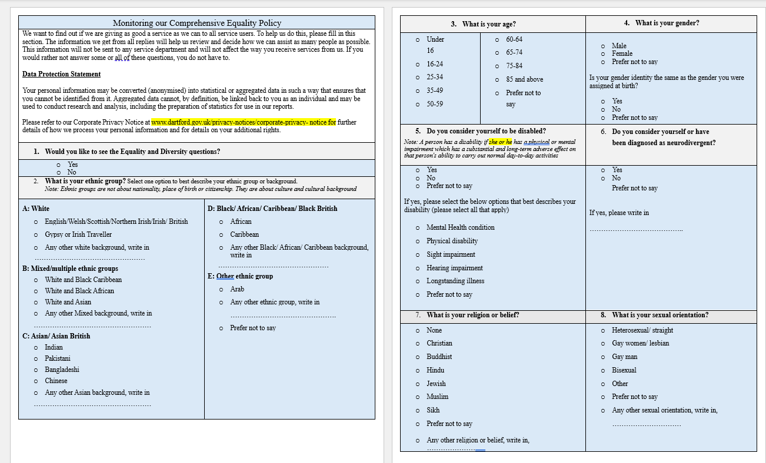

APPENDIX 5

We Asked, You Said, We did template

Consider points under Section 11 of the Toolkit when completing the template. You can use the two good practice examples in Appendix 6 to support you.

(Name of Consultation)- We Asked, You Said, We Did
We Asked
You Said
We Did

31

APPENDIX 6

Anonymised Examples
Example 1
We Asked | We asked for your views a Magazine to help us improve the magazine and ensure it includes more of the type of content you want to read.
You Said | We received 48 responses to the online questionnaire. The responses included:  - Four out of five respondents said they regularly receive XX magazine at home  - More than half of respondents spent five minutes or more reading the magazine with more than a third spending ten minutes or more  - Most respondents read and recycle the magazine but almost one in three keep it for future reference  - Almost half of respondents cited local community social media as their main source of local news and information with local newspapers, community newsletters and word of mouth all mentioned by around a third of responders  - Four out of five respondents would like to get information direct from the XX  magazine and two thirds from an eNewsletter. A third of responders use the council’s website for information and one in four access XX social media  - Almost 40% of respondents said they had accessed a service or attended an event they first learned about in the magazine  - At least 85% of respondents were happy with the content and 73% with the relevance of the content to themselves. Readability and design and layout both achieved 87% satisfaction.  You told us that the subjects of information you would most like to read about in the magazine are:  - Community news 48%  - Council and democracy: meetings, councilors 38%  - Parks and open spaces: walks and trails etc. 35%  - Community safety: tackling anti-social behavior etc. 33%  - Development & regeneration: housing, future plans etc. 32%  - Libraries services and events 31%  - Leisure: sports facilities, activities etc. 29%  - Consultations 27%  - Council Tax and budgets 26%  - What’s on: local venues, community events etc. 27%
We Did | We aim to distribute the magazine to every home in Dartford and we are working closely with our distributors to ensure as few homes as possible are missed. All missed addresses can be reported to management.  We are strengthening the link between XX magazine and XX Newsletter to ensure as many residents as possible are aware of and have access to the now weekly Newsletter.  Going forward we will aim to include more articles on the subjects that you have told us you are interested in reading about.  We will also be running some focus groups in the autumn to find out more about your views on XX magazine. We will add more information here when more details are available.

Anonymised Example 2
We Asked | We asked for your views on the Culture and Community Action Plan and the Wayfinding Action Plan for XX Town Centre. The Action Plans have been produced in response to the priorities set out in the XX Town Centre Strategy, in consultation with the local community.
You Said | We received 42 responses to the online questionnaire. 90% of respondents were Dartford residents. Over 60% of respondents have lived in the area for over 20 years.  The projects and actions people want prioritised from the responses included:  - boosting the visibility of existing cultural activities on the high street  - reviving under used spaces and encouraging better engagement with young people  - celebrating the unique local heritage of the area and promote its diversity; for example through commissioning of local artists and performers  - Facilitating and encouraging new and existing groups to connect and expand their networks.  The summary of responses to the Wayfinding Action Plan:  The majority of people strongly agree with the aims of the Wayfinding Action Plan  The projects and actions that people would like to see prioritised include:  - enhancing and celebrating the gateways and arrival points into the town centre  - improving greening in the town centre and signposting to the surrounding parks and greenspaces that are seen as an important part of the identity of XX  - Making the high street more welcoming and attractive – make it a destination by encouraging more independent retailers and celebrating the thriving food culture.  - Creating more spaces to dwell and meet.
We Did | We will be including the outcomes of the engagement into the emerging Public Realm Framework for the Town Centre and will also identify and deliver specific place making projects over the next 12 months.  The Town Team was established was October 2022 and meet monthly to explore and establish initiatives for improving the town centre. We will be supporting the Town Team to activate the temporary space at XX, and we will continue to do that to deliver on the Community priorities above. The Town Team organised and hosted a family focused art workshop in XX in the new space and further activation is planned over the course of the summer.

Anonymised Archiving Example 3
We Asked | We asked for families, and all those who support children and young people with SEND, including those in receipt of an Education, Health and Care Plan (EHCP) and children and young people who receive support through SEN Support for their views on the vision, aims, and priorities for the next three years set out in the Draft SEND Strategy.
You Said | We received 27 responses to the online questionnaire. You can read more about the results here (add link).
We Did | We made some changes to the draft strategy. You can read the final strategy here (add link)

